**OneMain Financial Code Challenge**

**Create a Kubernetes cluster with infrastructure as code:-**

Created cluster idli with eks-cluster.yaml (Used Infrastructure as a Code Cloud Formation)

=====================================================================================  
apiVersion: eksctl.io/v1alpha5  
kind: ClusterConfig

Metadata:

name: idli  
 region: us-east-2

nodeGroups:

- name: idli  
 instanceType: t2.small  
 desiredCapacity: 3

ssh:  
 publicKeyName: SZHSAT

====================================================================================

Executed command  
eksctl create cluster -f eks-cluster.yaml

It’s created EKS cluster idli

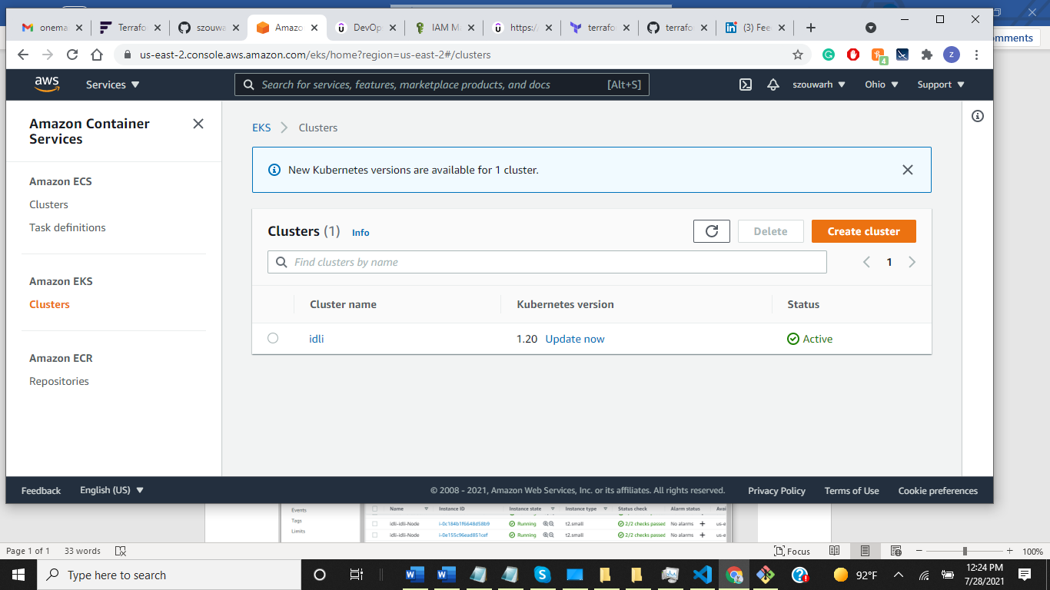

It’s also created 3 nodes as per yaml file defined.

kubectl get nodes;

NAME STATUS ROLES AGE VERSION

ip-192-168-30-167.us-east-2.compute.internal Ready <none> 178m v1.20.4-eks-6b7464  
ip-192-168-41-159.us-east-2.compute.internal Ready <none> 178m v1.20.4-eks-6b7464  
ip-192-168-76-214.us-east-2.compute.internal Ready <none> 178m v1.20.4-eks-6b7464

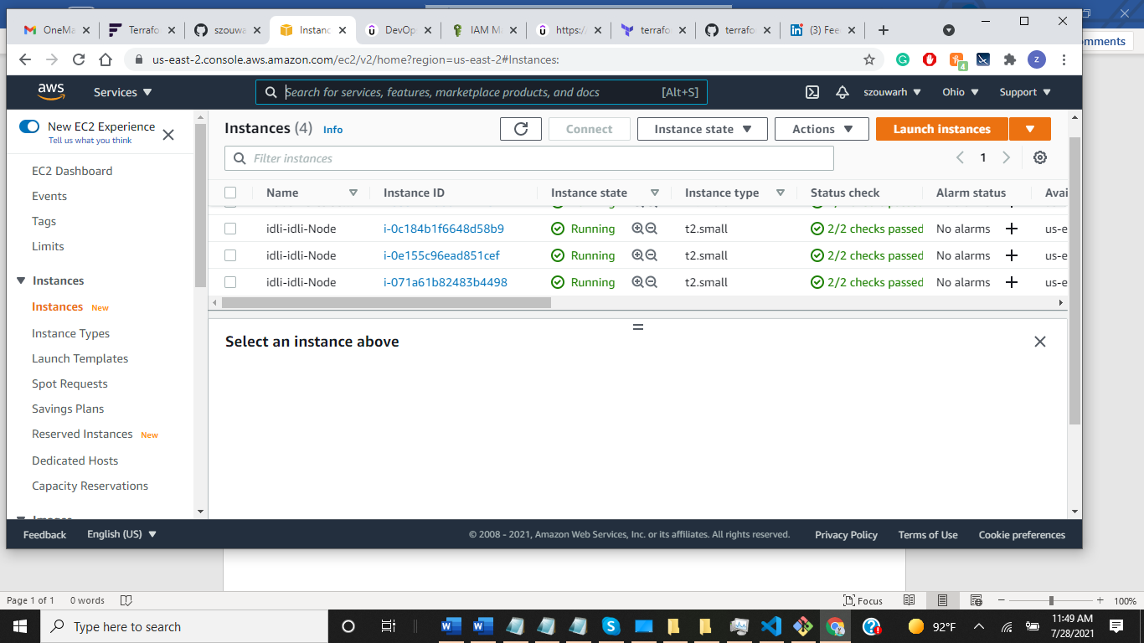

Delete the cluster:-  
eksctl delete cluster \  
--name idli \  
--region us-east-2